**PROJECT REPORT**

**NEWS TRACKER APPLICATION**

**CATEGORY:** Cloud App Development **TEAM ID: PNT2022TMID29362 TEAM MEMBERS**

# Aadhavan P Mohamed Musthapa N

**Vijay R Manojkumar K**

### TABLE OF CONTENTS

|  |  |
| --- | --- |
| **CHAPTER NO** | **TITLE** |
|  | ABSTRACT |
| **1** | **INTRODUCTION**   * 1. OVERVIEW   2. CLOUD COMPUTING |
| **2** | **LITERATURE SURVEY**   * 1. EXISTING PROBLEM   2. EXISTING WORKS   3. DAILYHUNT |
| **3** | **IDEATION & PROPOSED SOLUTION**   * 1. EMPATHY MAP   2. PROBLEM STATEMENT   3. PROPOSED SOLUTION |
| **4** | **MODULES AND DESCRIPTION**   * 1. FLASK   2. IBM CLOUD   3. IBM DB 2   4. IBM CONTAINER REGISTRY   5. DOCKER   6. IBM KUBERNETES CLUSTER   7. ARCHITECTURE   8. TECHNICAL STACK |
| **5** | **IMPLEMENTATION**   * 1. PREREQUISITES   2. FRONT END   3. BACK END |
| **6** | **SCREENSHOTS** |
|  | **REFERENCES** |

**ABSTRACT**

As our lives are very busy these days, we often feel we need more than 24 hrs. a day to cope up with everything we have in our schedule. Well, that's not possible but reducing the time by changing the conventional method of reading news can help. Just tell us what market news you're interested in and get a quick peek for the day. Only read what you feel is relevant and save your time. This app helps you to query for all information about Indices, Commodities, Currencies, Future Rates, Bonds, etc.… as on official websites. Front end is built using HTML 5, CSS 3 and JavaScript and we use python and flask framework for backend. Data is stored in IBM cloud using IBM DB2. This web app educates people about the world and also reduces their precious time.

* 1. **OVERVIEW**

# CHAPTER 1 INTRODUCTION

News Tracker application is a web app for news readers which uses RAPID API to get news and it is a full stack app which serves users for the purpose. The world is moving faster. Buying newspapers and

reading page by page is a time-consuming process. Our web app is a

solution for this ultimate goal by providing the latest news according to the user's interest.

### CLOUD COMPUTING

Cloud computing is the on-demand availability of computer system resources, especially data storage (cloud storage) and computing power, without direct active management by the user. Large clouds often have functions distributed over multiple locations, each of which is a data center. Cloud computing relies on sharing of resources to achieve coherence and typically uses a "pay as you go" model, which can help in reducing capital expenses but may also lead to unexpected operating expenses for users.

# CHAPTER 2 LITERATURE SURVEY

### EXISTING PROBLEMS

Newspapers are the first source that provided news for people. The modern or digital newspapers are called news apps or news feeds. Anytime, anywhere, access to the latest and updated news is reader’s demand. People like to get their news on the go, and expectations from news apps are dialed to the max.

What makes readers feel welcome? Newspapers may be struggling, but the news and information sector is alive and well. News finds its way to us on our smartphones and tablets, rather than being the painstaking embodiment of ‘message in a bottle’ arriving too little, too late.

### EXISTING WORKS

Daily hunt, Google news, BBC news, Flipboard, Reuters, Inshorts, Newspoint and Jio News are some top news apps which provide a good user experience and good content to read. These apps track user interest and suggest news according to it. But every app has some flaw in it. Let us take one previous work from above and discuss its working, merits and demerits and what needs to be improved.

### DAILYHUNT

#### Merits:

**Current news:** Dailyhunt provides news faster and updates user knowledge about current news. Notification: It notifies you when you get news about your favorite topic and also important news.

**Topics:** It offers vast amounts of topics. After you log in you can select your favorite topic, then the app keeps track of news related to your topic and provides news that only matters to you.

**Languages:** The app comes with 14 languages which helps us to read news in our own language.

**Personalized:** It provides personalized news feeds from diverse genres – Politics, Entertainment, Sports, Business, Weather, Astrology, Technology, Finance, Health and more.

**Trending News:** During Covid 19 Pandemic it helps a lot of persons to get news from official government sources and educate people about quarantine guidelines, restriction.

#### Demerits

**Organized News:** Even though it has a variety of topics it needs to be well collected and organized.

**No-Offline:** Some users may find some news as important but screenshotting every news is time consuming and takes memory from the user device. So, providing download news

options help users to save news inside the app and saves user time and memory.

**Location:** Providing news according to the user location is fine but more specified on it and not providing other regional news may affect users because that other regional news may be a topic which is selected by a user.

**Language based news:** When a user selects some regional language then news is more specific about that region this arises the same problem that happened with location.

**Repeated:** Repeating the same news over and over may cause loss of interest in users.

**Misleading Thumbnails:** Some news in app and thumbnails are totally not relatable which makes wasting of time and misleads users.

# CHAPTER 3

**IDEATION & PROPOSED SOLUTION**

### EMPATHY MAP

An empathy map is a collaborative tool teams can use to gain a deeper insight into their customers. Much like a user persona, an empathy map can represent a group of users, such as a customer segment. The empathy map was originally created by Dave Gray and has gained much popularity within the agile community.

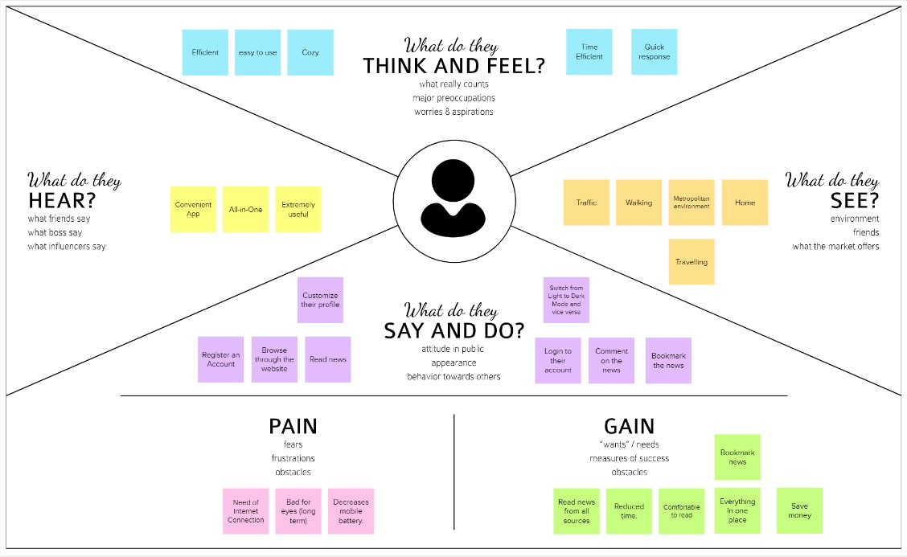

*FIG 3.1 Empathy map for News Tracker Application*

### PROBLEM STATEMENT

|  |  |  |  |  |  |
| --- | --- | --- | --- | --- | --- |
| **Problem Statement (PS)** | **I am (Customer)** | **I’m trying to** | **But** | **Because** | **Which makes me feel** |
| PS-1 | Student | search news about emerging  technology | can’t able to find what I need | there is no search bar or catalog to search, only option is scrolling through the end | Tired |
| PS-2 | Business Professional | get news about share market which is my regular search | I can’t able to find  anything related | this app haven’t tracking system | Frustrated |
| PS-3 | Jobless Person | find job related news | it repeats old news again and again | there is no specific  algorithm to avoid this issue | Tensed |
| PS-4 | Reporter | report about misleading news | can’t able to report my concern | there is no chatbot or  contact info to report | Useless |
| PS-5 | Common Man | read news i in offline | can’t able to do that | there is no download or save option | Worry |

* 1. **PROPOSED SOLUTION**

|  |  |  |
| --- | --- | --- |
| **S.NO** | **Parameter** | **Description** |
| 1 | Problem Statement (Problem to be solved) | Now-a-days it is hard to find news that is relevant to our interest and hard to interact with news apps which show repeated content again and again. User interfaces in news apps are not interactive. Users find difficulty to find the content that they are searching for and apps also contain misleading information. |
| 2 | Idea / Solution description | The News Tracker Application that we are developing will have a search bar which helps users to search for their  content and also our app will have a chat bot which will help users to satisfy their queries. It will also have dark mode  which helps users to read content  without concern about their eyes. Our app will have an user interface that will satisfy users' needs and their wants. We use flask which is a lightweight  framework that helps users to access our website for longtime without having to worry about battery consumption. |
| 3 | Novelty / Uniqueness | We use IBM Watson in our chat bot which will help to solve user queries.  Most news apps don't contain chat bots but it is necessary to have chatbots in news applications which will help both |

|  |  |  |
| --- | --- | --- |
|  |  | users and creators to get rid of fake news, misleading news and click bait. Search bar which will help users to search the content that they want and we will offer category tiles so that users can prioritize according to their interest.  Save post option which will help users to view their favorite news offline. |
| 4 | Social Impact / Customer Satisfaction | * Save time * User can read news offline * Chatbot helps to queries * Less Battery Consumption * User can customize according to their interest * Simple and interactive interface |
| 5 | Business Model (Revenue Model) | App will attract people of all ages who want to read news and it leads to more usage ­­­than it turns on investors’ interest. The app will have ads which are mostly related to user interest and these ads will generate revenue. |
| 6 | Scalability of the Solution | It provides Software as a service. From a small kid to a well grown man everyone can use our app to read their favorite news. It will save your time and battery.  It will have a variety of topics from education to entertainment and many more |

#### Brainstorming and prioritization

Brainstorming is a method design teams use to generate ideas to solve clearly defined design problems. In controlled conditions and a free-thinking environment, teams approach a problem by such means as “How Might We” questions. They produce a vast array of ideas and draw links between them to find potential solutions.

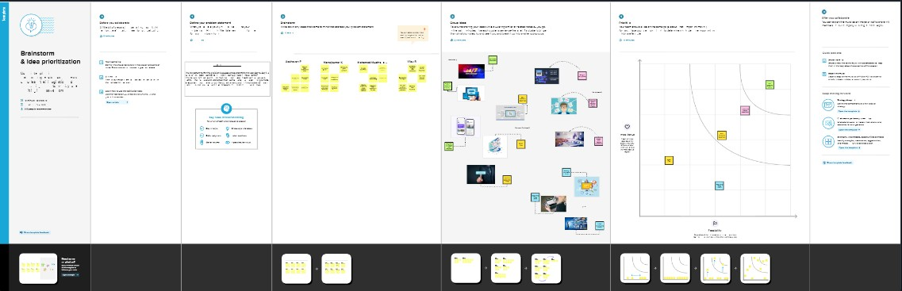

*FIG 3.2 Brainstorming & prioritization News Tracker Application*

#### Problem solution fit

Problem-solution fit is a term used to describe the point validating that the base problem resulting in a business idea really exists and the proposed solution actually solves that problem.

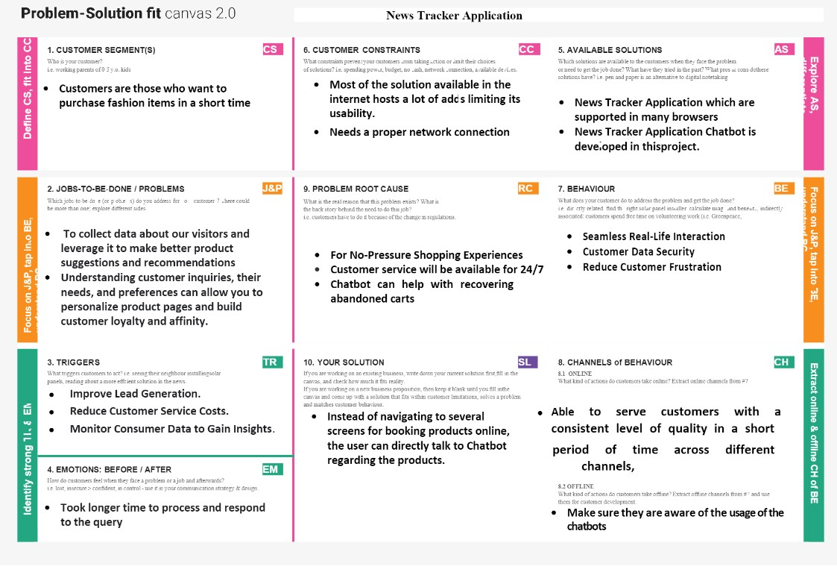

*Fig 3.3 Problem Solution Fit*

* 1. **FLASK**

# CHAPTER 4

**MODULES DESCRIPTION**

Flask is a micro web framework written in Python. It is classified as a microframework because it does not require particular tools or libraries. It has no database abstraction layer, form validation, or any other components where pre-existing third-party libraries provide common functions.

However, Flask supports extensions that can add application features as if they were implemented in Flask itself. Extensions exist for object-relational mappers, form validation, upload handling, various open authentication technologies and several common framework related tools.

### IBM CLOUD

IBM Cloud provides solutions that enable higher levels of compliance, security, and management, with proven architecture patterns and methods for rapid delivery for running mission-critical workloads.

### IBM DB 2

IBM Db2 is a family of data management products, including the Db2 relational database. The products feature AI-powered capabilities to help you modernize the management of both structured and unstructured data across on-premises and multi cloud environments.

### IBM CONTAINER REGISTRY

IBM Cloud Container Registry provides a multi-tenant private image registry that you can use to store and share your container images with users in your IBM Cloud account. The IBM Cloud console includes a brief Quick Start.

### DOCKER

Docker is an open platform for developing, shipping, and running applications. Docker enables you to separate your applications from your infrastructure so you can deliver software quickly. With Docker, you can manage your infrastructure in the same ways you manage your applications.

### IBM KUBERNETES CLUSTER

Kubernetes automates operational tasks of container management and includes built-in commands for deploying applications, rolling out changes to your applications, scaling your applications up and down to fit changing needs, monitoring your applications, and more—making it easier to manage applications.

IBM Cloud Kubernetes Service delivers powerful tools by combining Docker containers, the Kubernetes technology, an intuitive user experience, and built-in security and isolation to automate the deployment, operation, scaling, and monitoring of containerized apps in a cluster of compute hosts.

### ARCHITECTURE

Solution architecture provides the ground for software development projects by tailoring IT solutions to specific business needs and defining their functional requirements and stages of implementation. It consists of many subprocesses that draw guidance from various enterprise architecture viewpoints.

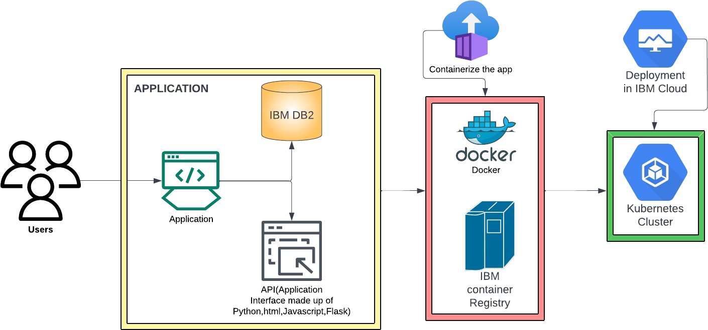

*FIG 4.1 SOLUTION ARCHITECTURE OF NTA*

The Solution architecture of the News Tracker Application model explains about software that are required to develop a web app. API in fig 4.1 is nothing but an application interface which is made up of using Python, Flask, HTML, CSS, Bootstrap and Java script.

### TECHNICAL STACK

A technology stack is a set of technologies that are stacked together to build any application. Popularly known as a technology infrastructure or solutions stack, technology stack has become essential for building easy-to-maintain, scalable web applications.

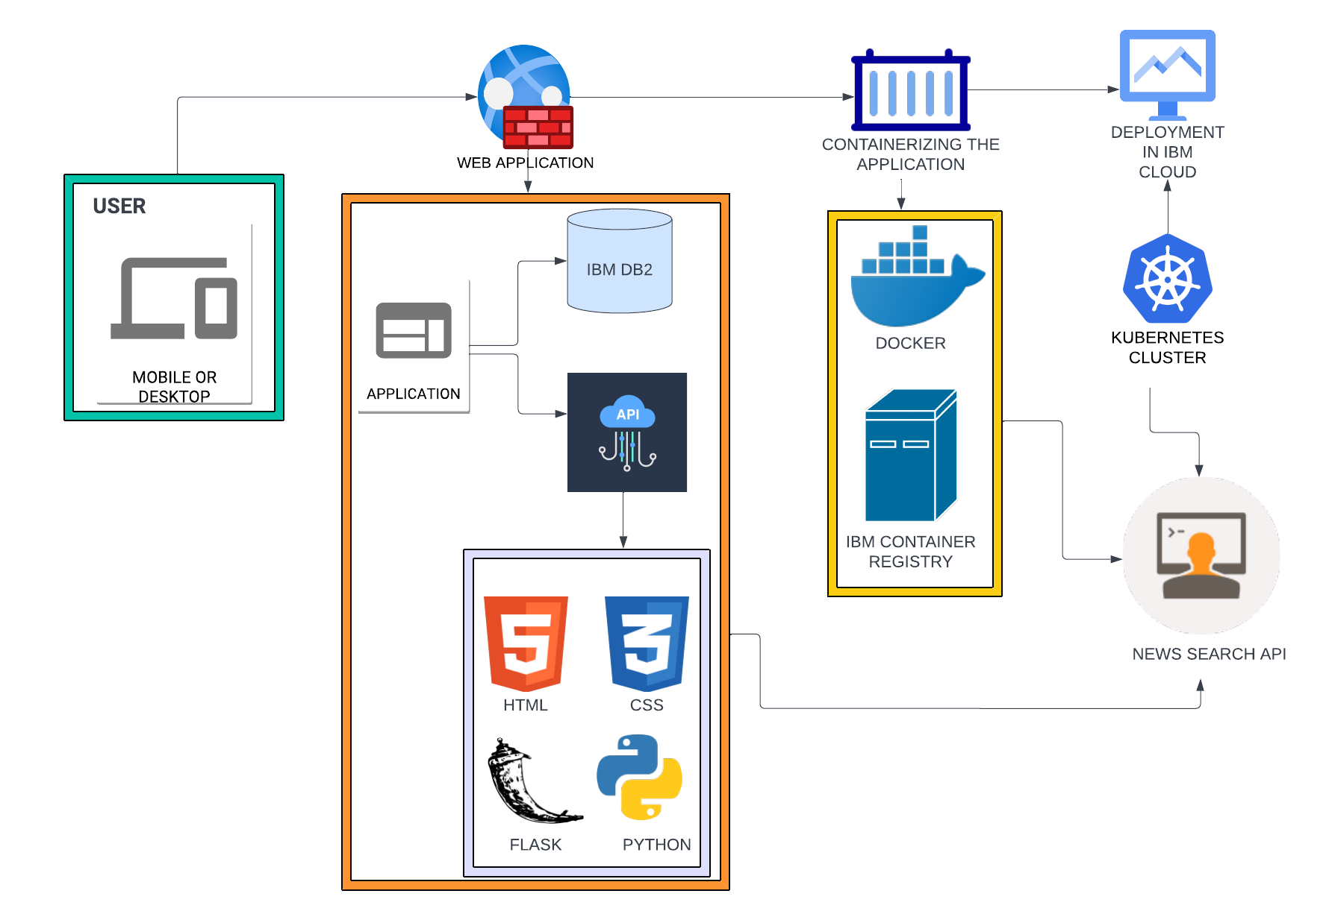

*FIG 4.2 TECHNICAL STACK OF NTA*

Users can use mobile or desktop to sign up/sign in. Then the

application connected to IBM DB 2 stored user data so it can be used to authenticate while the user signs in. The front end which is made up of

HTML, CSS, Java script helps users to access our application with ease and provide a good user experience.

Docker used to create images and by using IBM container registry we can containerize the app.

Kubernetes automates operational tasks of container management and includes built-in commands for deploying applications, rolling out changes to your applications.

News search API provides a key to connect with it, whose ultimate purpose is updating news for users according to the trend and users interests.

# CHAPTER 6 IMPLEMENTATION

### PREREQUISITES

Install python, flask, docker for desktop, open an account with IBM cloud and sendgrid which used to maintain email. After getting an IBM account buy IBM DB 2 or Cloudant where IBM DB 2 uses relational database whereas in cloudant we use non-relational database,IBM watson, IBM object storage, IBM container registry and IBM kubernetes cluster.

### FRONT END

Registration page, login page and dashboard need to be designed and developed which need to provide good user experience and also need to be simple but still efficient.

Dashboard contains a lot of things to explore. NEWS API

produces sufficient news for users and by using IBM Watson we created a chatbot whose ultimate goal is to help users to have easy access and it also helps users to report about anything that disturbed them.

These pages must be designed using HTML, CSS, Bootstrap and Javascript which can be opened using the web browsers. HTML pages are called templates in terms of flask css and other style elements need to be in a static folder.

### BACK END

We use python for development and a web framework called flask to create a web app. Flask used to connect every single html pages and css stylesheets and then most importantly IBM DB 2 then we need to connect IBM DB 2 with our html registration page and login page to store user input in database so we can use those data to authenticate an user while sign in.

For the index page we need to use RAPID NEWS API which generates news for a user which requires a key to connect with the flask app. After we get it we need to connect it using that authentication and generate the news that we wanted for our web app.

After we create a responsive web app we need to create an image using Docker, then we need to use IBM container registry to store and run it with the help of Kubernetes cluster.

# CHAPTER 6 SCREENSHOTS

PNT2022TMID29263

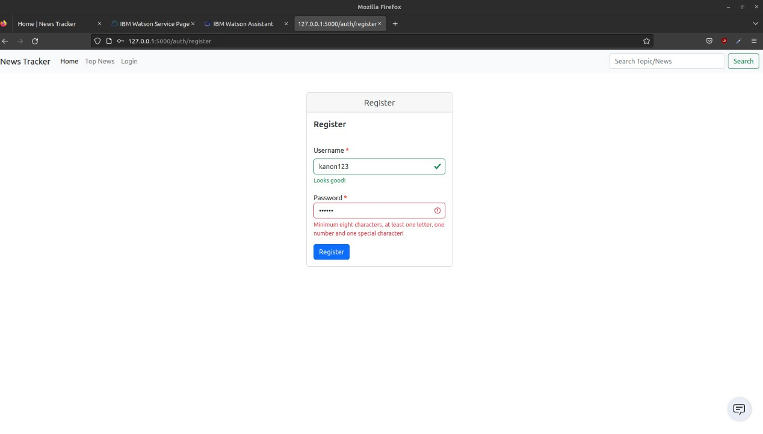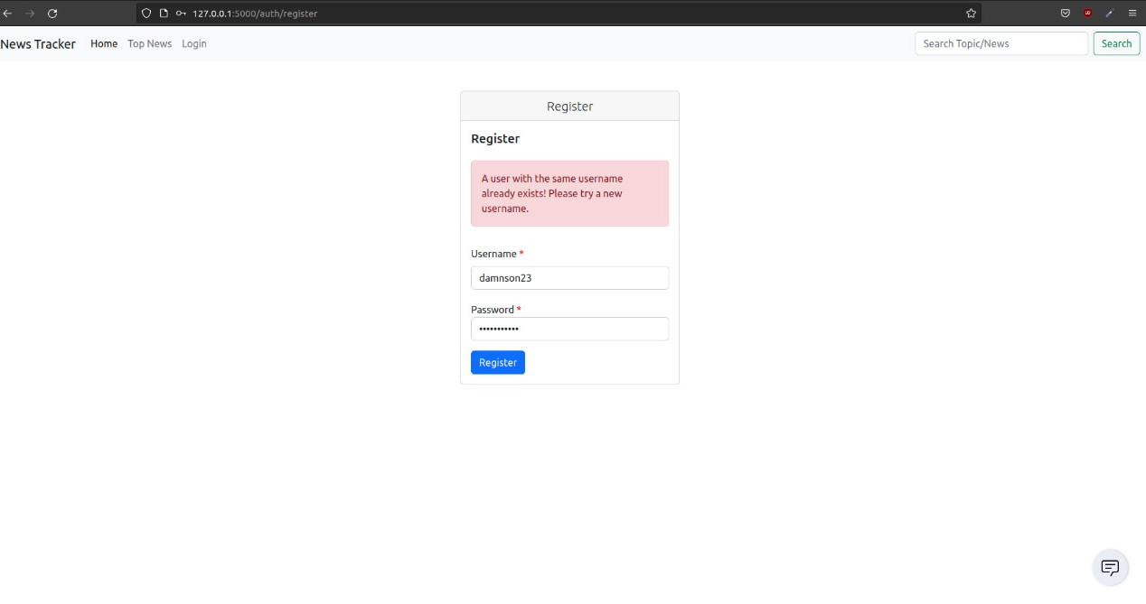

PNT2022TMID29263

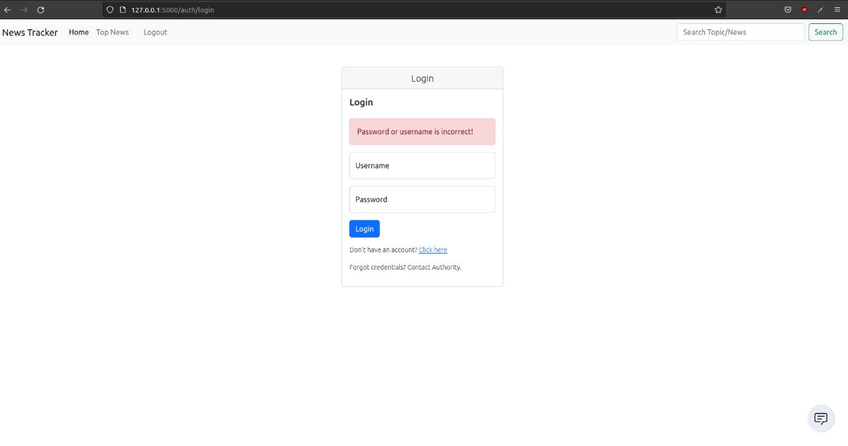

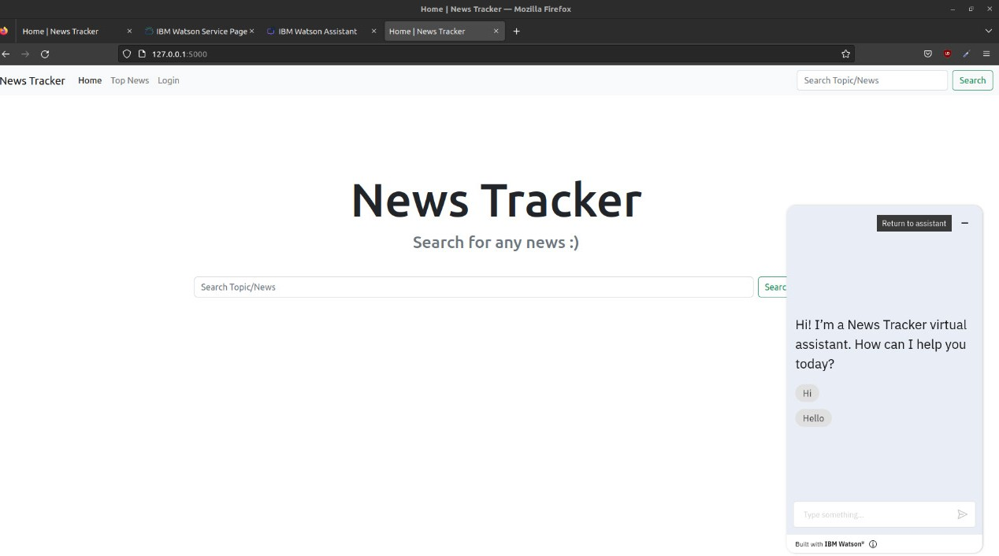

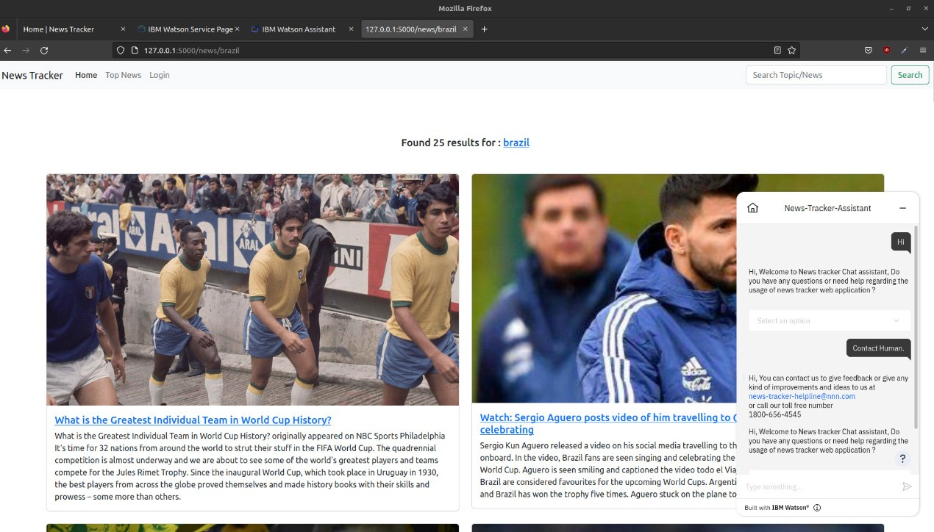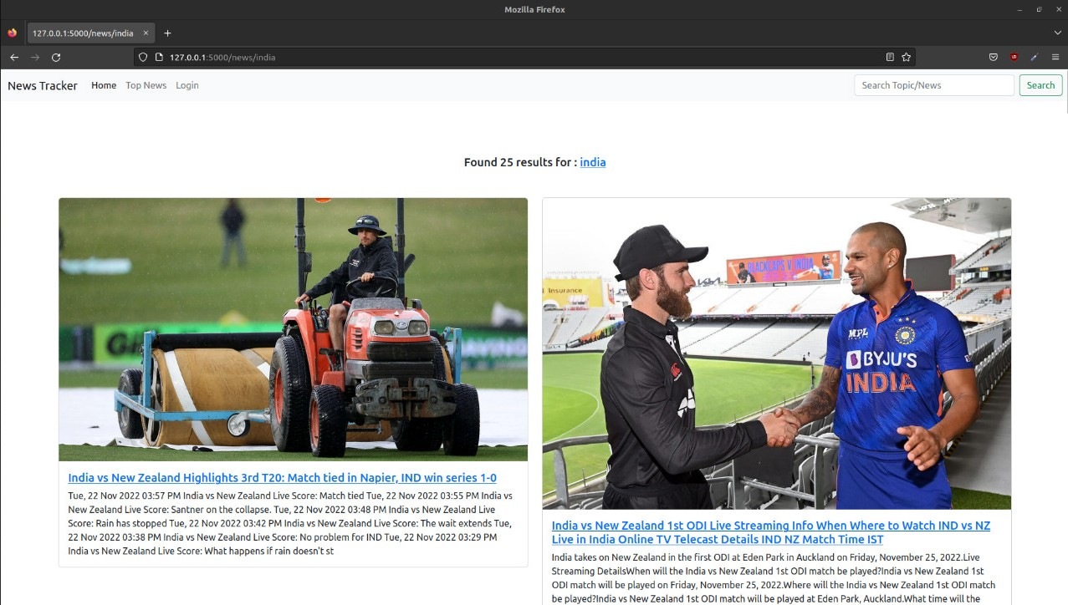

PNT2022TMID29263

PNT2022TMID29362

**REFERENCES**

1. [**https://cloud.ibm.com/logi**](https://cloud.ibm.com/login)**n**
2. [**https://www.ibm.com/in-en/cloud**](https://www.ibm.com/in-en/cloud)
3. [**https://flask.palletsprojects.com/en/2.2.x/**](https://flask.palletsprojects.com/en/2.2.x/)
4. [**https://labs.play-with-docker.com/**](https://labs.play-with-docker.com/)
5. [**https://kubernetes.io**](https://kubernetes.io/)**/**
6. [**https://www.lucidchart.com/pages/**](https://www.lucidchart.com/pages/)
7. [**https://getbootstrap.com/**](https://getbootstrap.com/)
8. [**https://newsapi.org/registe**](https://newsapi.org/register)**r**
9. [**https://en.wikipedia.org/wiki/Dailyhunt**](https://en.wikipedia.org/wiki/Dailyhunt)
10. [**https://en.wikipedia.org/wiki/Cloud_computing**](https://en.wikipedia.org/wiki/Cloud_computing)

## PROJECT LINK

h[ttps://github.com/IBM-EPBL/IBM-Project-22781-1659858111](https://github.com/IBM-EPBL/IBM-Project-22781-1659858111)

## DEMO VIDEO

https://youtu.be/L4bWmnCylpI